Thoor Ballylee to get much needed clean up
GALWAY ADVERTISER, FEBRUARY 14, 2013.
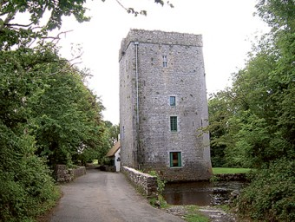
Thoor Ballylee.
By Kernan Andrews
Maintenance work around the famous ‘Yeat’s tower’ of Thoor Ballylee, in south County Galway is due to begin, following a lengthy period of consultation.
Following severe flooding in 2009 and 2010 the tower and its grounds were left severely damaged. After nearly two years of consultation with Failté Ireland, the Lady Gregory & Yeats Trail Group obtained permission to engage Tús - Galway Rural Development, to start the maintenance work.
The Lady Gregory and Yeats trail group welcome this partnership to improve the site coming into the tourist season. Thoor Ballylee is one of eight sites included in the Lady Gregory and Yeats Heritage Trail.
The trail seeks to promote south Galway by linking sites between Loughrea and Gort which have associations with Lady Gregory and WB Yeats. The group’s website can be viewed at www.ladygregoryyeatstrail.com

